THEORY QUESTIONS
1.
(a)

The diagram below shows the electrical method of magnetizing a nail.
Study the diagram and use it to answer the questions that follow.
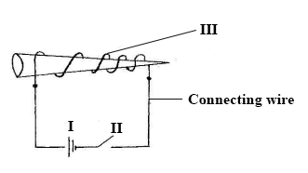
(i)

Give the names of the parts of the circuit labelled I, II and III.
(ii)

List two substances that can be made into a magnet.
(iii)

State two other methods of making magnets.
(iv)

Name one material that is used in making an electrical wire.
(v)

Give two properties of the material you named in (iv) which makes it useful as a wire.
(b)

The diagram below shows the set-up for the preparation of carbon dioxide in the laboratory.
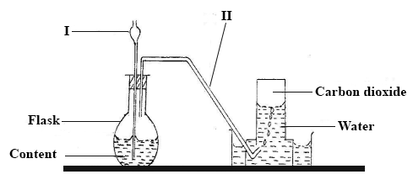
(i)

Name the parts of the set-up labelled I and II.
(ii)

Give the name of the method of gas collection shown in the diagram.
(iii)

Give one property of gases collected over water.
(iv)

What will happen if component I does not dip into the contents of the flask?
(v)

List two compounds that form the content of the flask.
(vi)

Write down the systematic name of carbon dioxide.
(c)

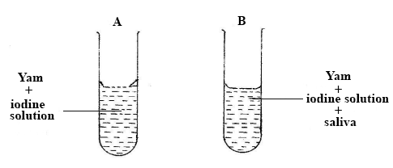
In an experiment, yam pap is put into two test tubes A and B containing iodine solution.
The test tubes are warmed slightly to a temperature of 37ºC and saliva is put into test tube B.
(i)

State the colour of the content of the test tube A.
(ii)

State the colour changes of the contents in test tube B after 3 minutes.
(iii)

Fehling's solution is added to the contents of test tube B after the 3 minutes and it turns brick-red. What food substance is present?
(iv)

Give two functions of saliva in eating.
(v)

Why was it necessary to warm the contents of the test tubes to about 37ºC?
(vi)

Give two aims of the experiment.

2.
(a)

(i)

State two conditions that are required for photosynthesis to take place.
(ii)

How would you show that starch is formed during photosynthesis?
(b)

Write a balanced chemical equation to show the reaction between hydrogen and oxygen.
(c)

(i)

What is a satellite?
(ii)

Give one example of a natural satellite.
(iii)

List two uses of artificial satellites.

3.
(a)

Define
(i)

self-pollination
(ii)

cross-pollination
(b)

State two ways in which cross-pollinated plants are better than self-pollinated plants.
(c)

Sodium chloride is prepared by the reaction between dilute hydrochloric acid and sodium hydroxide.
(i)

Write a balanced equation for the reaction.
(ii)

What is the name given to this reaction?
(d)

Describe an experiment to show that pressure acts in all directions in a liquid.

4.
(a)

(i)

What is a vector of a disease?
(ii)

State two methods each by which the vectors of the following diseases can be destroyed:
(α)

river blindness;
(β)

malaria.
(b)

Write down the systematic names of the following compounds:
(i)

CaCo₃;
(ii)

FeS;
(iii)

NaCl;
(iv)

NaOH.
(c)

(i)

Give the two properties that are common to all states of matter.
(ii)

In an experiment to determine the density, a stone of mass 60 g is put into a bowl containing water. If the level of the water rises from 60 cm³ to 75 cm³, determine the density of the stone.

5.
(a)

Mention five differences between plants and animals.
(b)

Define each of the following terms, giving one example in each case:
(i)

Compound;
(ii)

Element.
(c)

(i)

Give two differences between an electrical insulator and a conductor.
(ii)

Draw and label a simple electrical circuit made up of a cell and a switch connected to two electric bulbs connected in parallel.

